**Academic Year: 2022-23 Name of Student:**

**Semester: V Student ID:**

**Class / Branch/ Div: TE- IT A/ B Roll No:**

**Subject: IP Lab Date of Submission:**

**Name of Instructor:**

**Experiment No:8**

**Aim:** Write a program to demonstrate Class Component & Functional Component using

React JS.

**Software Used:** Visual Studio code

**Prerequisites:** HTML, CSS, REACT JS

**Code & Output:**

**Index.js for Functional Component:**

import Reactdom from 'react-dom';

import "./index.css";

import App from "./App";

Reactdom.render(

<App color='red' />, document.getElementById('root')

);

**App.js**

import { Component } from "react"

import tree from './tree.jpg';

import './index.css';

function App(props){

return(

<div>

<h3 className="red">my App color is {props.color}</h3>

<h1 className="hh">welcome to react world</h1>

<h2>This is my first Component</h2>

<a className="a1" href="https://www.google.com">click me to relocate google.com</a><br></br>

<img src={tree} width="40%" height="50%x" ></img>

</div>

);

}

export default App;

**Output of Functional component:**

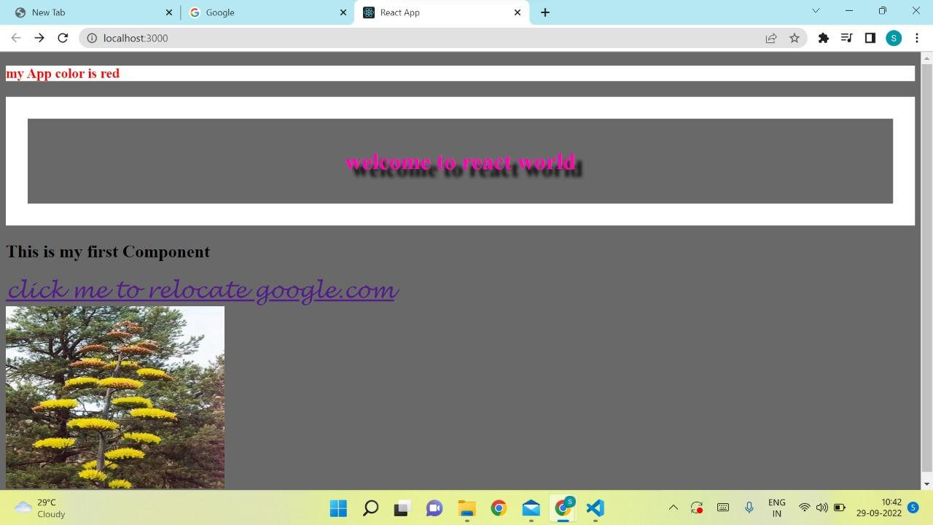

**Conclusion:** Thus, we have studied and implemented how to create functional with their syntax. Also learned & implemented ‘Props’ in those components to assign properties to them.